The development environment and tools

1. Visual studio 2019

2. SQL Server 2019 (Express Edition)

Download url: https://www.microsoft.com/en-in/sql-server/sql-server-downloads

3. SSMS

Download url: https://docs.microsoft.com/en-us/sql/ssms/download-sql-server-management-studio-ssms?redirectedfrom=MSDN&view=sql-server-ver15

Technology Stack

1. Dot Net Core 2.1

2. Identity Server

3. EF Core 2.1

4. EF Model

5. Dependency Injection Repository Design

After all installation take the latest pool of master

1. Navigate to source project folder and double click on PharmaGoApp.sln, it will open project inside Visual Studio(VS).
2. Presh Ctrl+Shift+B command will build the solution.
3. Navigate to Tools =>Nuget Package Manager =>Package Manager Console.
4. It will open cli

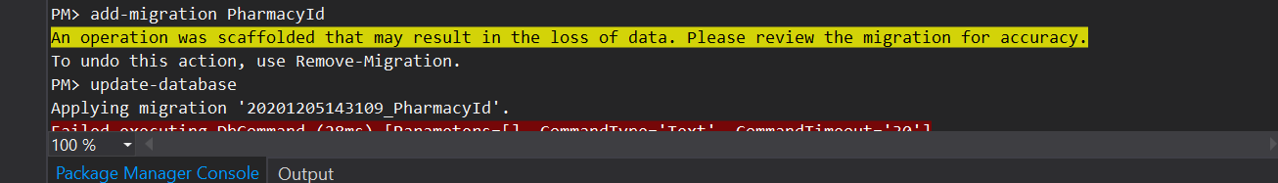

1. Now type add-migration InitialSeeding_Some random_number
2. Now fire update-database
3. Open SSMS and ensure that GPADb is created.

If No

go to DAL layer GPADBContext class and change Server name with your local server.

Repet step again

1. Navigate to Web Project PharmaGoApp => DbScripts=>PopulateRoles.sql

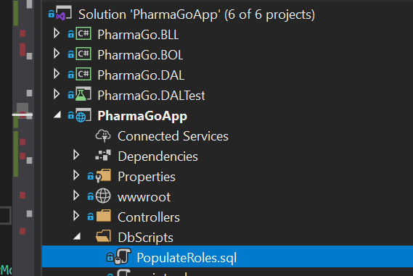

1. Open file inside SSMS(Sql Server Management Studio) and execute it.
2. All Set Up is done now run application and use it.
3. The very first Sign Up will be treated as Admin Sign Up.

In case of any query/help reach to us on gopharmaappcontact@gmail.com.